**CURRICULUM VITAE**

NAME Tia Wahyu Eka Ningsih

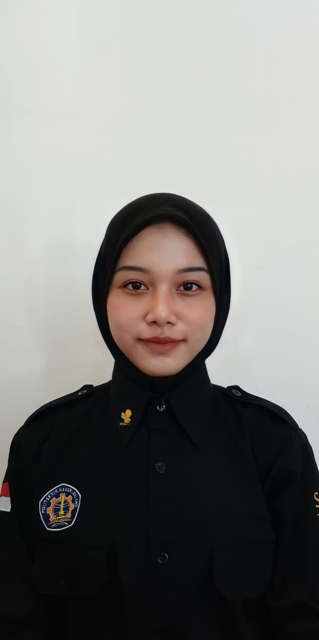

ADDRESS Jl. Sakri Gg Guyub Rukun,

RT 3 RW 2, Kec. Sutojayan

Kab. Blitar, Jawa Timur

Personal details should be shown at the beginning

PHONE NUMBER 0857 4881 3742

DATE OF BIRTH April 11, 2001

NATIONALITY Indonesian

MARITAL STATUS Single

**EDUCATION**

State formal educational courses

2013 – 2016 SMPN 01 Sutojayan

2016 – 2019 SMAN 1 Sutojayan, Science Major

2019 – Now Polytechnic State Of Malang, Associate’s Deegre

Informatic Management

**ORGANIZATION EXPERIENCE**

State non-formal educational courses

2019 – Now UKM PASTI

( Pasukan Anti Narkotika Politeknik Negeri Malang )

Secretary Bidang 2 Pencegahan

**OTHER WORKSHOPS AND TRAININGS**

State any workshops or trainings you have attended

July - October, 2021 Digital Talent Scholarship VSGA Kominfo, Junor Graphic Design Scheme.

September - October, 2021 Certification Software Programming BNSP, Polytechnic State of Malang

**PORTFOLIO**

Mention your present job first and work backwards

* System Library GUI Design with Netbeans
* Medical Android Application Design with Flutter
* Damaged road reporting Information System Web Design
* Trip of Mountain Web Design with Framework Laravel

Hobbies, interests and other relevant information

* Create a Game Endless 2D and 3D with Unity

**INTERESTS**

Design Interface, Videographer, Fotographer

Date your CV with:

Month-Year

October, 2021